SERVICENOW PROJECT DOCUMENTATION

METRO TICKET GENERATING SYSTEM IN SERVICENOW

Name | PRASANNA N
Dept | Artificial Intelligence and Data Science
College | K.Ramakrishnan College of Technology

TABLE OF CONTENTS

S.No | TITLE | PAGE NO.
1 | PROJECT OVERVIEW | 3
 | 1.1 OVERVIEW | 3
 | 1.2 OBJECTIVE | 3
 | 1.3 SCOPE | 3
2 | PHASE 1 – REQUIREMENT ANALYSIS & PLANNING | 5
 | 2.1 BUSINESS OBJECTIVES | 5
 | 2.2 FUNCTIONAL SCOPE | 6
 | 2.3 STAKEHOLDER MAPPING | 6
 | 2.4 EXECUTION ROADMAP | 6
3 | PHASE 2: BACKEND DEVELOPMENT & CONFIGURATIONS | 8
 | 3.1 DATA ARCHITECTURE | 8
 | 3.2 AUTOMATION LOGIC | 11
 | 3.3 BUSINESS RULES | 13
4 | PHASE 3: UI/UX DEVELOPMENT AND CUSTOMIZATION | 15
 | 4.1 INTERFACE DESIGN | 15
 | 4.2 NAVIGATION FLOW | 16
 | 4.3 USABILTY | 16
5 | PHASE 4: DATA MIGRATION, TESTING & SECURITY | 18
 | 5.1 DATA HANDLING | 19
 | 5.2 ACCESS CONTROL | 19
 | 5.3 QA TESTING | 19
 | 5.4 DATA INTEGRITY | 20
6 | CONCLUSION | 20

PROJECT OVERVIEW

  - OVERVIEW
The Metro Ticket Generating System in ServiceNow is a ServiceNow-based application developed to provide a simple and automated process for booking metro tickets for Chennai Metro. The system allows users to enter their journey details, including the starting station, destination station, travel date, number of passengers, and journey type. Users can select either a single journey or a return journey and choose their preferred payment method.
The system uses ServiceNow features such as Service Catalog, Catalog Variables, Client Scripts, Business Rules, Script Includes, UI Policies, database tables, approvals, and notifications to automate the ticket booking process. The application also maintains metro station and fare information in dedicated tables, allowing the system to validate journey details and calculate the applicable ticket fare.
Since an actual payment gateway is not integrated into the current project, the payment process is simulated using a System Administrator approval mechanism. After the user submits the booking request, the System Administrator reviews and approves the payment. Once the approval is completed, the system confirms the booking and generates the metro ticket.
  - OBJECTIVE
To develop an automated and user-friendly Chennai Metro ticket booking and generation system in ServiceNow that streamlines the journey from ticket request to booking confirmation while demonstrating ServiceNow's Service Catalog, scripting, business rules, approval workflows, data management, and notification capabilities.
  - SCOPE
The Metro Ticket Generating System in ServiceNow is designed to enable users to book Chennai Metro tickets through the ServiceNow platform. Users can enter their starting station, destination station, travel date, and passenger count, and choose between a single journey or return journey.
The system allows users to select their preferred payment method during the booking process. As an actual payment gateway is not integrated into the current project, the payment process is simulated through an approval mechanism by the System Administrator. Once the payment approval is received, the system confirms the booking and generates the metro ticket.
The project covers the complete ticket-generation workflow, including user input, station and fare validation, fare calculation, journey selection, payment selection, administrative approval, ticket confirmation, and notification.

PHASE 1 – REQUIREMENT ANALYSIS & PLANNING

2.1 BUSINESS OBJECTIVES
The primary business objective of the Metro Ticket Generating System in ServiceNow is to digitize and automate the metro ticket booking process, providing commuters with a convenient and structured method of generating tickets without relying on traditional manual ticketing processes.
Enhance Commuter Convenience:
Provide users with a simple and user-friendly digital interface through ServiceNow where they can select their starting station, destination station, travel date, passenger count, and journey type. The system is designed to reduce the effort required to book a metro ticket and provide a faster and more accessible booking experience.
Automate the Ticket Booking Process:
Automate the major stages of ticket generation, including station selection, fare calculation, journey validation, payment selection, approval, and ticket confirmation. This reduces manual intervention and ensures that the booking process follows a consistent workflow.
Improve Fare and Booking Accuracy:
Maintain metro station and fare information in structured ServiceNow tables and use system logic to determine the applicable fare based on the user's journey. This helps reduce errors that may occur during manual fare calculation or ticket preparation.
Support Digital Payment Processing:
Provide users with options to select their preferred payment method as part of the booking process. In the current project implementation, since a live payment gateway is not integrated, payment confirmation is simulated through an approval process by the System Administrator. The ticket is generated only after the required approval is completed.
Improve Operational Management:
Use ServiceNow's workflow, approval, automation, and notification capabilities to provide better control over ticket requests. The system allows administrators to review and approve payment requests while maintaining a clear status throughout the booking process.
Enable Future Digital Transformation:
The system provides a foundation that can be extended in the future with features such as QR-code-based digital tickets, real-time payment gateways, mobile ticketing, booking history, analytics, and integration with metro services.

2.2 FUNCTIONAL SCOPE
The system provides a Service Catalog item for metro ticket booking, allowing users to enter their journey details such as Source, Destination, Passenger Type, Number of Tickets, Travel Date, and Journey Type. Based on the selected journey details, the system performs automated fare calculation using the configured metro fare data. Users can select a preferred payment method, and since a live payment gateway is not integrated in the current implementation, the payment is processed through System Administrator approval. Once the request is approved, the system confirms the booking and generates the digital metro ticket. The system is designed to support QR-code-based digital ticket generation as a future enhancement.

2.3 STAKEHOLDERS MAPPING
The system provides a Service Catalog item for metro ticket booking, allowing users to enter their journey details such as Source, Destination, Passenger Type, Number of Tickets, Travel Date, and Journey Type. Based on the selected journey details, the system performs automated fare calculation using the configured metro fare data. Users can select a preferred payment method, and since a live payment gateway is not integrated in the current implementation, the payment is processed through System Administrator approval. Once the request is approved, the system confirms the booking and generates the digital metro ticket. The system is designed to support QR-code-based digital ticket generation as a future enhancement.

2.4 EXECUTION ROADMAP
The project was executed through a series of planned milestones to develop the Metro Ticket Generating System in ServiceNow. The implementation started with the Catalog Form Setup, where the ticket booking form and required variables were configured to capture passenger and journey details. The Fare Logic was then implemented to automatically calculate the ticket fare based on the selected source, destination, passenger count, and journey type. Station Details Mapping was configured to connect the booking form with the station and fare data stored in ServiceNow.
The next milestone was the Flow and Approval process, which automates the booking workflow and sends the request to the System Administrator for payment approval. After approval, QR Code Generation was integrated to create a digital QR code for the confirmed ticket. The system then triggers an Email Notification containing the ticket details and QR code and delivers it to the user. Finally, the complete application was tested and prepared for Deployment.

Execution Flow
Catalog Form Setup → Fare Logic → Station Details Mapping → Flow & Approval → QR Code Generation → Email Notification → Testing & Deployment

PHASE 2: BACKEND DEVELOPMENT & CONFIGURATIONS

3.1 DATA ARCHITECTURE
The Metro Ticket Generating System uses three main ServiceNow tables to organize and manage the application's data. The tables separate station information, fare information, and ticket/booking information, making the system structured, maintainable, and easier to automate.
1. Metro Station Details Table
The Metro Station Details table stores the master information of Chennai Metro stations. It contains details such as Station Name, Station Code, Location, and Station Sequence. The station records are used as reference data in the ticket booking process, allowing users to select their starting and destination stations from the available stations.

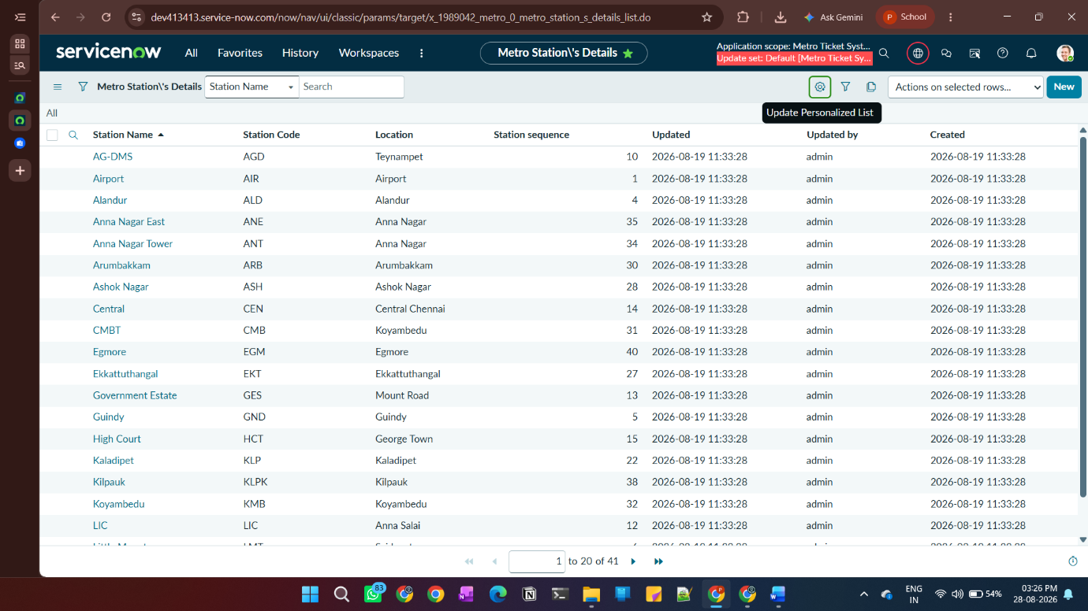

The station table provides the station references used in the fare table, while the ticket table uses the station and fare information to create and manage individual booking transactions. This architecture separates master data from transaction data and supports accurate fare calculation and automated ticket generation.

2. Metro Fare Details Table
The Metro Fare Details table stores the fare information for different station combinations. It contains references to the Starting Station and Destination Station, along with the corresponding Single Journey Fare and Return Journey Fare. This table is used by the fare calculation logic to determine the applicable ticket amount based on the user's selected journey.

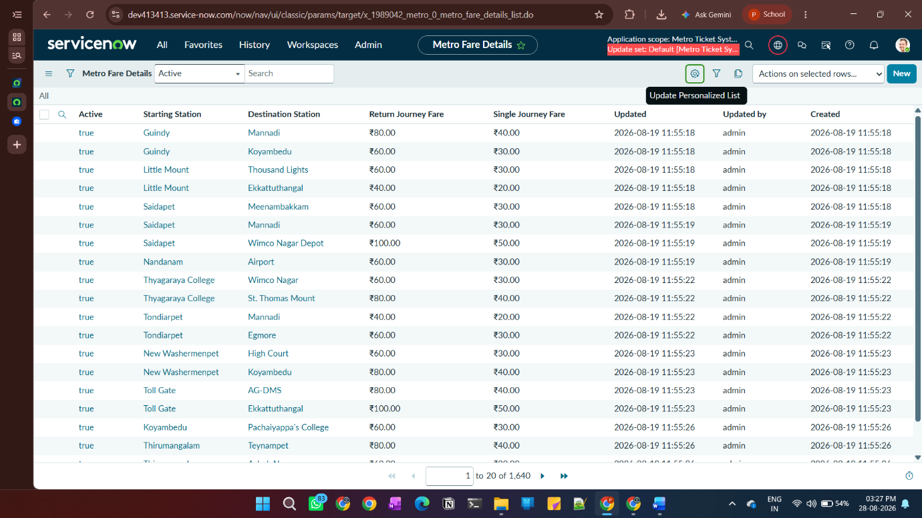
3. Metro Ticket Details Table
The Metro Ticket Details table stores the complete information related to each ticket booking. It contains details such as Ticket Number, Passenger, Starting Station, Destination Station, Travel Date, Number of Passengers, Journey Type, Mode of Payment, Single/Return Journey Amount, Total Amount, Booking Status, Payment Approver, Payment Reference, and QR Data. This table acts as the main transaction table and maintains the ticket information throughout the booking, approval, confirmation, and QR-code generation process. 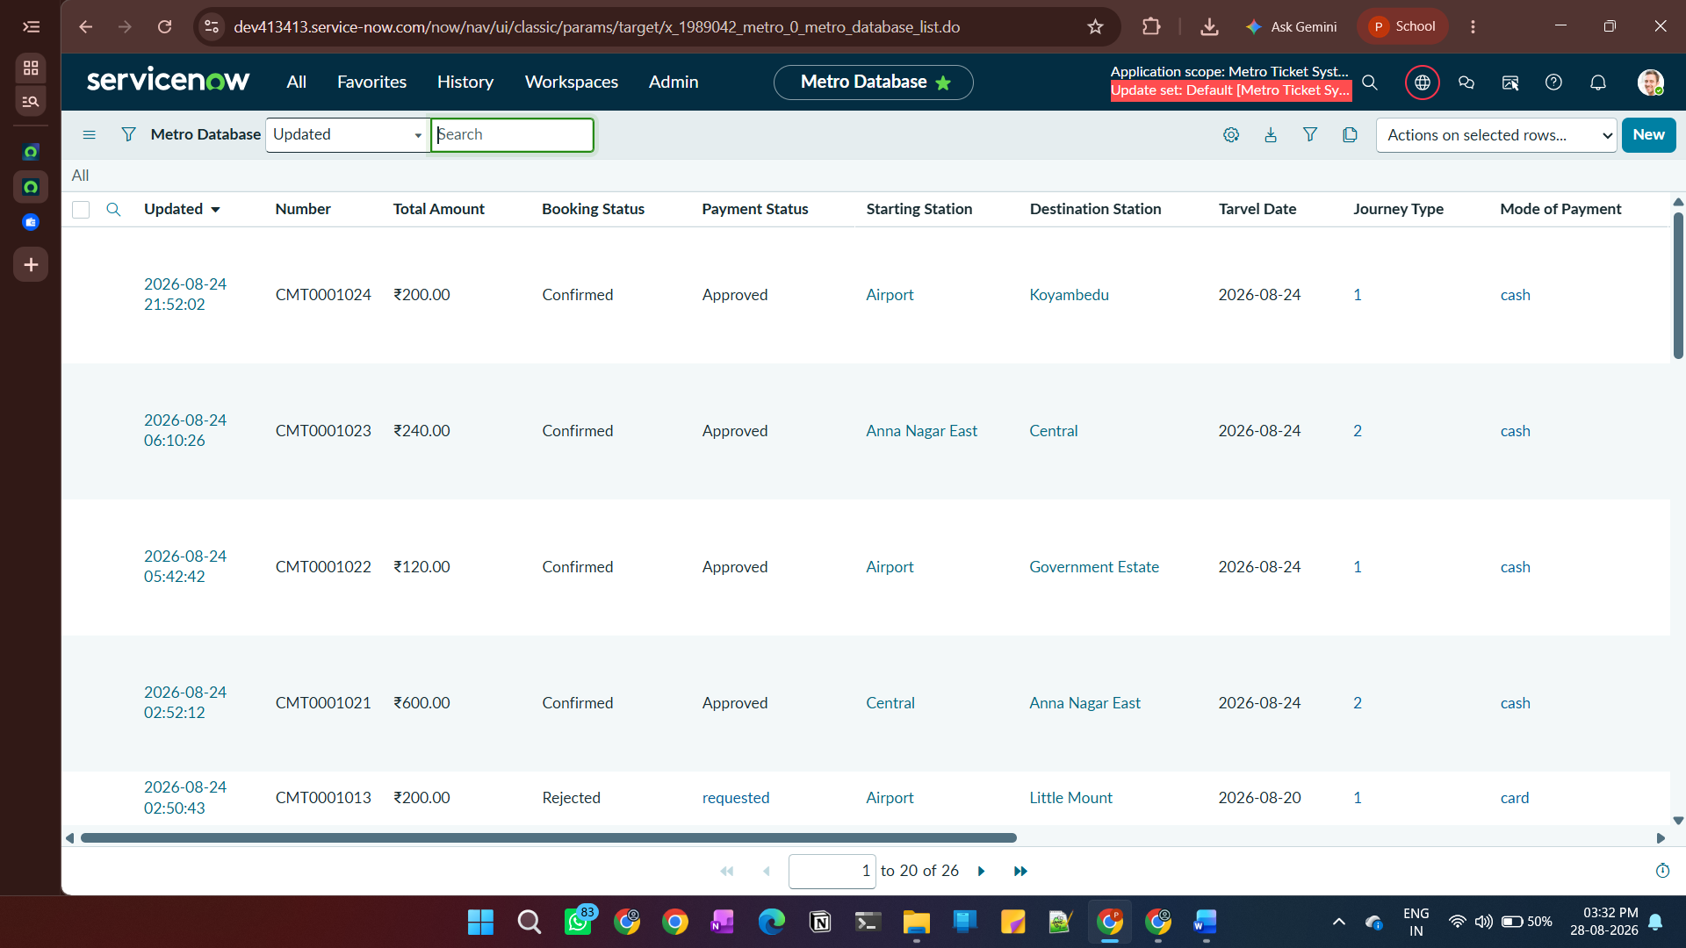
Data Relationship
The overall data structure can be represented as:
Metro Station Details → Metro Fare Details → Metro Ticket Details
The station table provides the station references used in the fare table, while the ticket table uses the station and fare information to create and manage individual booking transactions. This architecture separates master data from transaction data and supports accurate fare calculation and automated ticket generation.
Service Catalog – Book a Metro Ticket
A Service Catalog item named “Book A Metro Ticket Item” was created to provide users with a structured interface for booking metro tickets. The catalog item collects the required journey, passenger, and payment information through configurable variables. These inputs are then used by the backend logic for fare calculation, validation, approval, and ticket generation.
The catalog item contains 10 variables, including reference fields for station selection, journey and payment choices, passenger details, and custom fields for displaying the calculated fare.

Catalog Variables
Variable | Type | Purpose
Starting From | Reference | Select the starting metro station
Going To | Reference | Select the destination station
Travel Date | Date | Specify the date of travel
No of Passengers | Single Line Text | Enter the number of passengers
Type of Journey | Multiple Choice | Select Single or Return Journey
Estimated Fare | Single Line Text | Display the calculated fare
Mode of Payment | Multiple Choice | Select the preferred payment method
Enter Payment Mode | Single Line Text | Capture additional payment details when required
Amount of Single Journey | Custom | Display the single journey fare
Amount Including Return | Custom | Display the return journey fare
The Starting From and Going To variables are reference fields connected to the Metro Station Details table, ensuring that users select valid stations from the configured station data. The selected journey details are processed by the fare calculation logic to determine the applicable amount.
The catalog item also includes Catalog Client Scripts and Catalog UI Policies to control field behavior, perform validation, and dynamically display or calculate relevant information based on the user's selections.

Booking Input Flow
Station Selection → Travel Details → Passenger Count → Journey Type → Fare Calculation → Payment Method → Ticket Request
This catalog item acts as the primary user entry point to the Metro Ticket Generating System, connecting the user-facing booking process with the backend tables and automation configured in ServiceNow.
3.2 Automation Logic
The Metro Ticket Generating System uses ServiceNow automation to reduce manual processing and ensure accurate ticket creation. A Number Maintenance configuration is used for the Metro Database table to automatically generate unique ticket numbers with the CMT prefix. This provides each booking with a distinct ticket reference for tracking and identification.
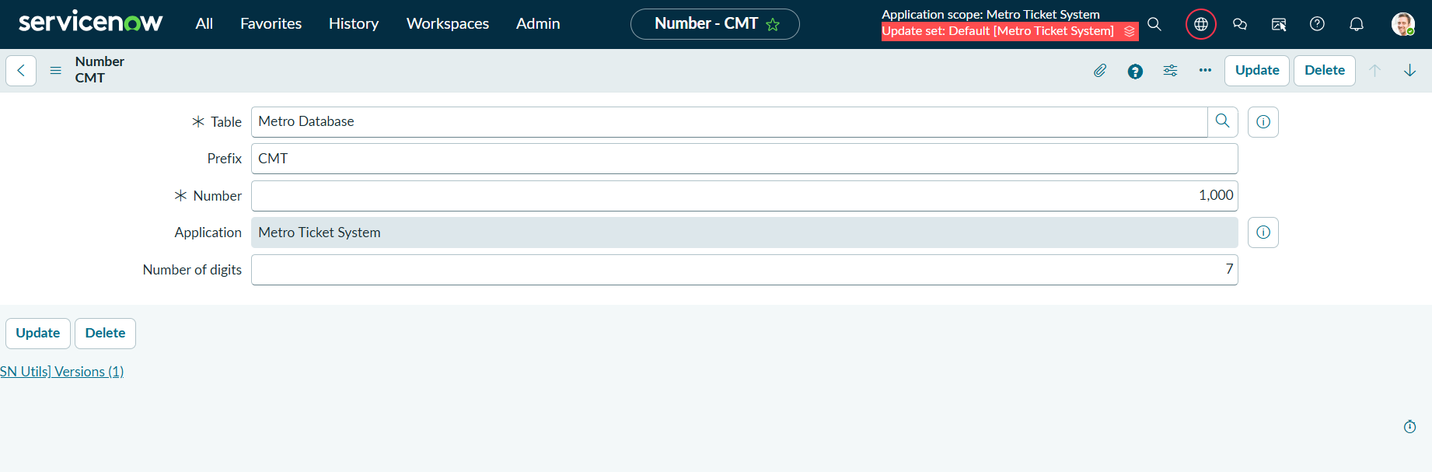
Catalog Client Scripts are used to automate the booking form at the user interface level. The scripts calculate the metro fare dynamically based on the selected source, destination, journey type, and passenger details. They also validate the passenger count to ensure that users enter an acceptable value before submitting the booking request. These validations help prevent incorrect data from entering the ticketing workflow and improve the overall booking experience.
A Flow Designer workflow named “Metro Ticket Booking Flow” was implemented to automate the complete ticket booking process. The flow is triggered when a user submits the Book A Metro Ticket Service Catalog request. It first retrieves the catalog variables and looks up the corresponding fare record using the selected starting and destination stations. A Metro Database record is then created with the booking details and calculated fare.
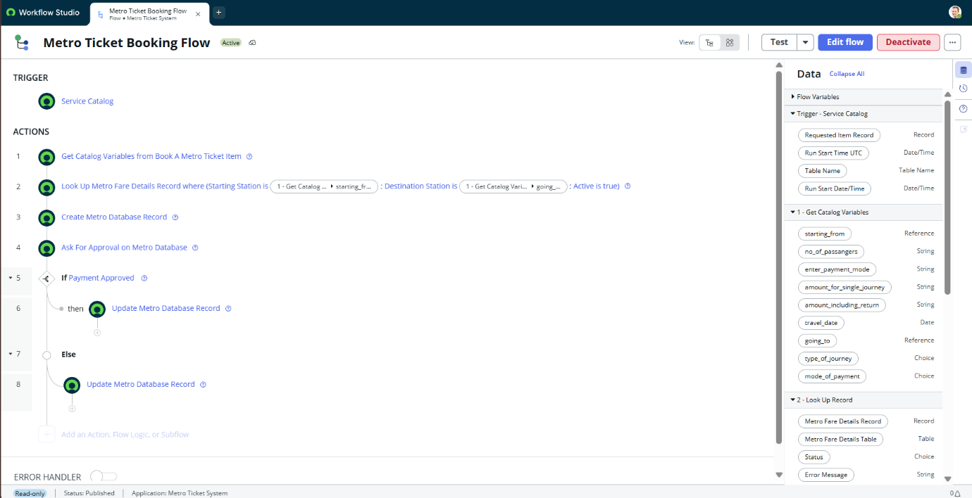
The flow sends the ticket record for approval by the System Administrator to simulate the payment authorization process. If the payment is approved, the Metro Database record is updated to reflect the successful booking, allowing the ticket to proceed to confirmation and QR-code generation. If the approval is not granted, the record is updated accordingly to indicate that the booking was not approved. This flow ensures that the complete ticket booking and approval process is automated and consistently managed within ServiceNow.

Automation Components
Component | Automation
Number Maintenance | Automatically generates unique ticket numbers with CMT prefix
Fare Calculation Client Script | Calculates the applicable metro fare
Flow Designer | Automate the process of Metro Ticket Booking
Result: The automation ensures that ticket numbers, fare calculations, and passenger inputs are handled consistently without requiring manual intervention. Using the flow to get values , update records and initialize the approval logic, helps to automate the full process of metro ticket booking.
3.3 Business Rules
A Business Rule named “Generate Metro QR Data” was implemented on the Metro Database table to automatically prepare the data required for digital QR-code ticket generation. The rule is configured to execute when an existing ticket record is updated and checks the Booking Status before generating the QR information.
The Business Rule ensures that a QR code is generated only after the ticket reaches the Confirmed status. If the booking is not confirmed, the qr_data field is cleared to prevent QR information from being associated with an unconfirmed ticket.
For a confirmed ticket, the rule collects the relevant booking information, including ticket number, passenger, starting station, destination station, travel date, number of passengers, journey type, payment method, and total amount. These details are combined into a structured QR payload and stored in the QR Data field of the Metro Database record.
The stored QR data is subsequently used by the email notification script to generate the QR image and include it in the confirmed ticket email sent to the passenger.

Business Rule Workflow
Ticket Updated → Check Booking Status → Confirmed? → Generate QR Data → Store in QR Data Field → Email Script Generates QR → Send Digital Ticket

Key Configuration
Configuration | Value
Business Rule | Generate Metro QR Data
Table | Metro Database
Execution | Before Update
Purpose | Generate QR payload for confirmed tickets
QR Data Field | qr_data
Trigger Condition | Booking Status = Confirmed
Result: The Business Rule connects the ticket confirmation process with QR-code generation, ensuring that only successfully confirmed tickets receive valid digital QR information.

PHASE 3: UI/UX DEVELOPMENT & CUSTOMIZATION

4.1 INTERFACE DESIGN
The Book A Metro Ticket Service Catalog item was designed as the primary interface for users to submit metro ticket requests. The form provides fields for selecting the starting station, destination station, travel date, number of passengers, journey type, and mode of payment. Reference fields are used for station selection to ensure that users select valid stations from the configured metro station data.
The interface also displays the applicable fare based on the user's selections. Mandatory fields, appropriate field types, and organized placement of variables were used to make the booking form clear and easy to understand.

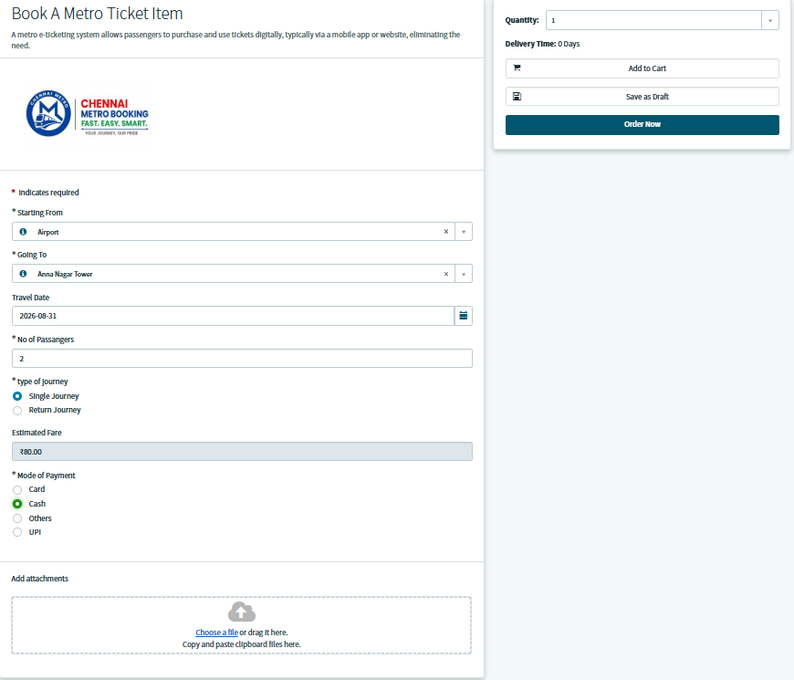

4.2 NAVIGATION FLOW
The navigation flow describes how the user moves through the ticket booking process from submitting the catalog request to receiving the confirmed ticket. The user begins by opening the Book A Metro Ticket catalog item and entering the required journey details. After submission, the request is processed through the automated workflow, where the fare is determined and the ticket record is created.
The request then moves to System Administrator approval for payment authorization. Once approved, the booking status is updated to confirmed, the QR code is generated, and the confirmation email containing the digital ticket is sent to the user.
Navigation Flow:
Service Catalog → Book A Metro Ticket → Enter Details → Submit Request → Fare Processing → Admin Approval → Ticket Confirmation → QR Code → Email Notification
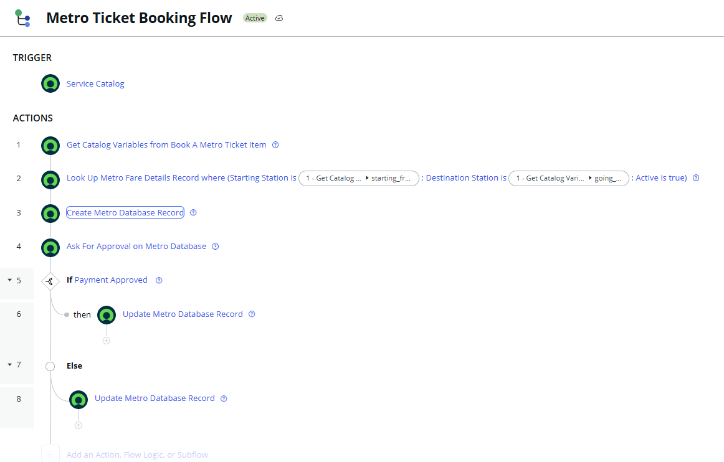

4.3 USABILTY
The system is designed to provide a simple and convenient booking experience with minimal user interaction. Users only need to provide the required travel and payment information, while fare calculation, ticket numbering, approval processing, QR-code generation, and email notification are handled automatically by ServiceNow.
Client-side validation helps prevent incorrect passenger counts and other invalid inputs before submission. The use of station reference fields reduces data-entry errors, while the confirmation email provides the user with all important ticket information and the QR code in one place.
Final Email Notification:
Confirmed Ticket Mail preview:
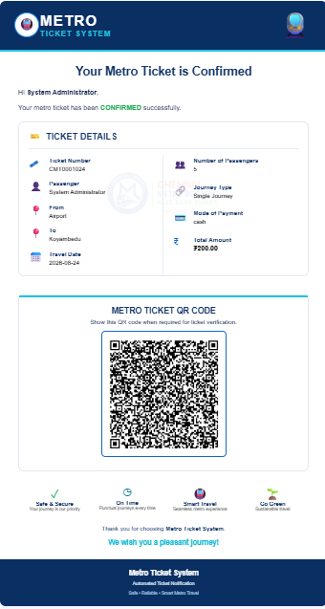
Rejected Ticket Mail preview:
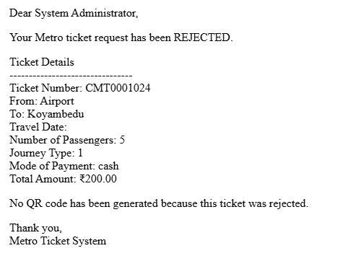

PHASE 4: DATA MIGRATION, TESTING & SECURITY

5.1 DATA HANDLING
The system uses structured ServiceNow tables to manage Chennai Metro station, fare, and ticket information. Station and fare data were prepared in Excel and imported into the respective ServiceNow tables using Import Sets and Transform Maps. The Metro Station Details table contains station information, while the Metro Fare Details table maintains the fare combinations for different source and destination stations. Ticket-related information is stored separately in the Metro Database table.

5.2 ACCESS CONTROL
Access to the application is managed based on the responsibilities of the users. Passengers are provided access to the ticket booking functionality through the Service Catalog, while Administrators have access to manage ticket records and handle the approval process. Administrative activities such as payment approval and backend data management are restricted to authorized users to maintain controlled access to the system.

5.3 QA TESTING
The application was tested to verify that each stage of the ticket booking process works as expected. Testing covered station selection, passenger count validation, journey type selection, fare calculation, payment selection, ticket creation, administrator approval, QR-code generation, and email notification. Both valid and invalid inputs were tested to identify and prevent errors before ticket confirmation.
Sample Test Scenarios:
Test Scenario | Expected Result
Select valid source and destination | Stations accepted
Enter valid passenger count | Booking proceeds
Enter invalid passenger count | Validation message displayed
Select Single Journey | Single fare calculated
Select Return Journey | Return fare calculated
Admin approves request | Ticket status becomes Confirmed
Ticket confirmed | QR code generated
Confirmation completed | Email with ticket and QR code sent

5.4 DATA INTEGRITY
Data integrity was maintained by using reference fields for station selection and validating the booking information before processing. Fare records are mapped to the appropriate starting and destination stations, ensuring that the correct fare is used during ticket generation. The system also ensures that QR data is generated only for confirmed tickets, preventing unapproved bookings from receiving a valid digital ticket.
And the QR has the details of the ticket and can be retrieved by the scanners
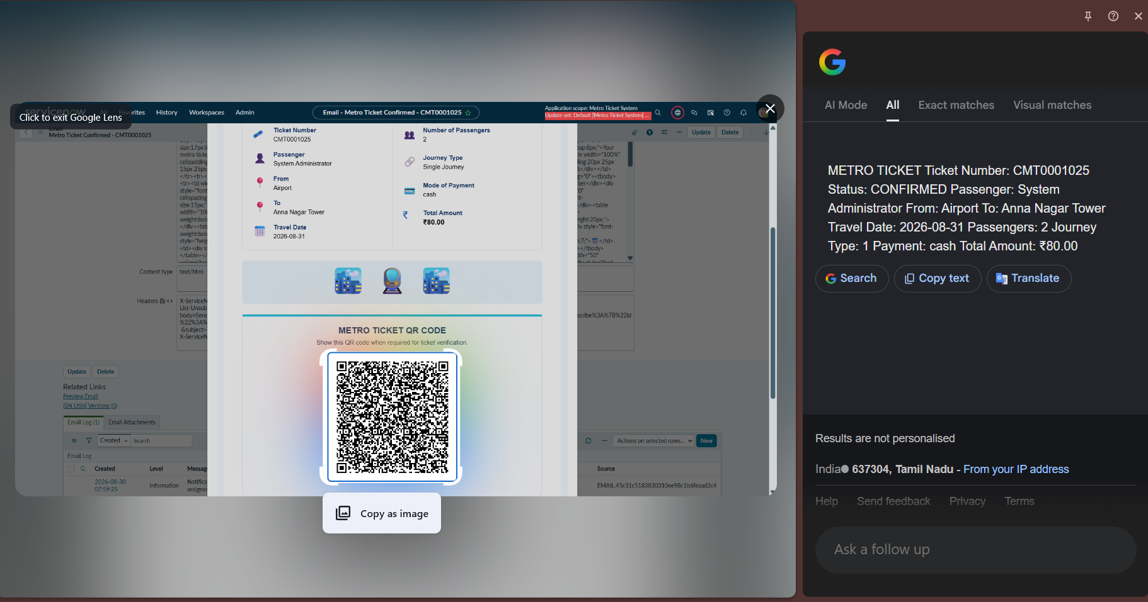

Overall Result: The data migration, access controls, testing, and validation processes ensure that the Metro Ticket Generating System maintains accurate, consistent, and controlled data throughout the ticket booking lifecycle.

CONCLUSION
The Metro Ticket Generating System in ServiceNow successfully provides a digital and automated solution for Chennai Metro ticket booking. The system enables users to enter their journey details, including source, destination, travel date, passenger count, journey type, and payment method, through a Service Catalog interface.The application integrates station and fare data, automated fare calculation, ticket number generation, validation, Flow Designer automation, System Administrator approval, QR-code generation, and email notifications into a single ticketing workflow. The use of ServiceNow automation reduces manual processing and ensures that tickets are generated only after the required approval is completed.
Overall, the project demonstrates how ServiceNow can be used to build a structured, user-friendly, and automated metro ticketing application, while providing a foundation for future enhancements such as real-time payment integration, advanced analytics, and additional digital travel services.

